1. Find the ename,eno,salary of an employee whose salary is greater than 4000.



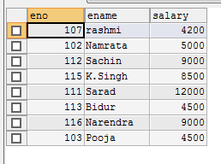

2. Find the eno , ename , salary of an employee whose salary is **greater than 4000** and job status is **professor**.



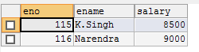

3. Find the eno ename salary of the employee whose **dept no 20** or **job status research fellow**

select eno, ename, salary from employee

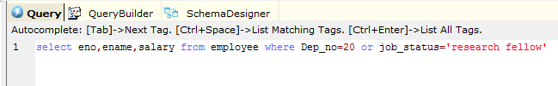

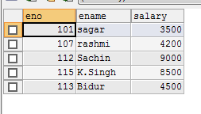

4.Find the eno,ename,age and salary from the employee where the **age is in between 24 and 28.**



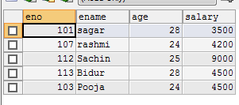

5. Find eno,ename whose starting letter ‘Sa’



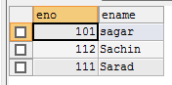

6. List all employee names with their project name.



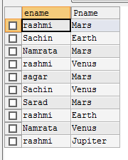

7. List name of all employees and their salary who are working in project **mars or venus**.



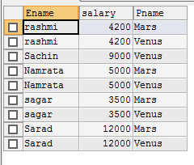

8. List name of all employees and their salary who are working in project ‘**earth’ and ‘venus’**.

9. List name and address of all employees who works in department which is located in ‘**pokhara’.**